**Quantum Learning Lab (QuLL) User Facility – Pilot Program**

The QNM Workforce Development team proposes establishing a first of its kind Quantum Learning Lab (QuLL) User Facility that can help address the nation’s critical need for a quantum workforce by providing hands-on learning opportunities to students, educators, and professionals in New Mexico (NM). Hands-on training is one of the most important skillsets for a quantum-ready workforce [1] and one of the most difficult to obtain due to the sparsity, expense, and complexity of quantum research labs. To reach a larger, more diverse audience and help meet current workforce demands, we propose to build a user facility that is specifically designated as quantum learning lab where students gain experience with real hardware and experiments related to quantum technologies.

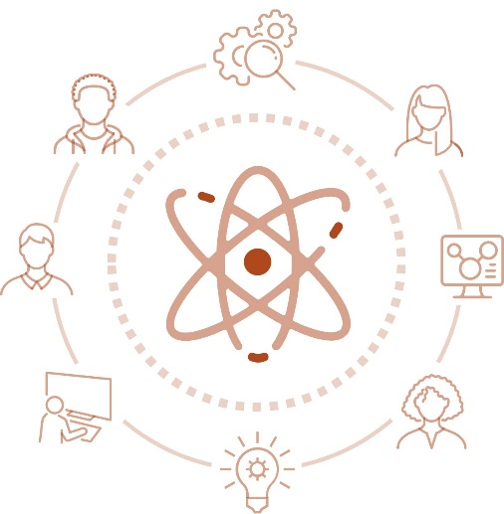**Pilot Program Goal**: Our goal is to introduce quantum technologies based on atomic systems in an accessible manner by providing hands-on experiments that are paired with learning modules that can be adapted to a wide range of user backgrounds and education levels. Through this pilot program we will focus on neutral atom systems, as they are relatively low cost, applicable to broadest number of regional employers, relevant to quantum computing, sensing, and communication, and allows for introduction of quantum concepts without advanced education. Through this pilot program we will create open-source resources that are aligned with the key knowledge, skills, and abilities of quantum technician roles and needs [ref QED-C report], and that can be delivered through non-traditional training pathways.



**QuLL**

*Develop spring 2024 |* ***Launch Fall 2024***

8-10 week program, hosted at CNM Ingenuity, and taught by SME’s from Sandia and CNM. The program is aimed at developing proof of concept curricula and demos to help train quantum technicians and build new educational pathways.

**4-6 Students**

**BOOTQamp**

**Experiments:**

|  |
| --- |
| **MOT Experiment**  *The capstone demo of all the other parts.  Lock a laser, align it to the MOT cell, turn on the oven, tune the magnetic field to demonstrate a MOT. Learn about laser cooling and magnetic trapping.*  Impact: Demonstrates technical components and targeted concepts required for quantum sensing, communication, and computing with atomic systems.  **Job Opportunities:** AFRL, LANL, Sandia, Atom Computing, SDL, Quantinuum, Infleqtion, IonQ, Stable Laser Systems, Vescent, Toptica |
| **Ultrahigh vacuum**  *Build and pump down a vacuum system to 10^-9 Torr, using roughing, turbo, and ion pumps, as well as troubleshooting.*  Impact: Utilized in most atomic-based quantum applications, as well as many other qubit technologies.  **Job Opportunities:** AFRL, LANL, Sandia, Atom Computing, SDL, Quantinuum, Infleqtion, IonQ, Stable Laser Systems, Maybell Quantum, IBM, Intel, Google, Amazon… |
| **Absorption spectroscopy**  *Align a laser to an atomic vapor cell, identify the spectroscopic features associated with atomic resonances, tune the extended cavity diode laser to the appropriate atomic resonance, and lock it using standard feedback.*  Impact: Utilized in any atomic-based quantum application requiring laser addressing to tune the laser to the appropriate wavelength  **Job Opportunities:** AFRL, LANL, Sandia, Atom Computing, Space Dynamics Lab, Quantinuum, Infleqtion, IonQ, Stable Laser Systems, Vescent, Toptica |

**Program Partners:** The effort will be launched as a joint effort between Sandia Labs, CNM Ingenuity, and AFRL. Once the pilot program is launched the team would like to expand to LANL, UNM, NMSU, NMT, and NTU. Additionally, the team is looking to engage community partners, quantum industry, and educational partners to help support and launch the effort.

**Conclusion:** To the best of our knowledge, the QuLL User Facility would a first-of-its-kind facility, with potential to draw nation-wide interest and provide a crucial training need for the next generation quantum workforce. With guidance from quantum researchers at Sandia National Labs, QuLL will be largely community driven, with relevant experiments determined by industry, national lab, and university researchers, with the lab manuals/curricula developed by a coalition of NM partners. Through this pilot program we wish to demonstrate what can be done to provide critical hands-on skills in experimental quantum technology for students and attract and secure funding to expand efforts to meet emerging QIS workforce needs. Additionally, QuLL will supplement other ongoing efforts such as QCaMP, our high school quantum summer camp (QCaMP), enabling us to ***reach broader audiences in NM and provide pathways into the field of quantum that would otherwise be unavailable***.

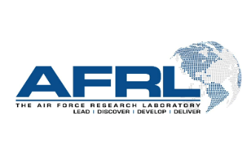

1. “Quantum Information Science and Technology Workforce Development National Strategic Plan” https://www.quantum.gov/wp-content/uploads/2022/02/QIST-Natl-Workforce-Plan.pdf